**Exercise 1: Inheritance**

Hospital. A program which displays a list of hospital employees in a ListBox. The program has an Employee class which has a name, address and phone number. We then create a new class Nurse which extends Employee and another class Doctor which also extends Employee. Both of these classes have additional attributes. We create a number of objects of each class and display.

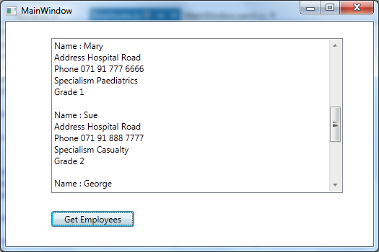

**Exercise 2: Use of base**

Working on the example above we are going to use base to refer to constructors and methods from the base class in the derived class. Note that the default constructor is called in the base class if we do not specify a particular constructor.

**Exercise 3: Overriding methods**

We will override a method to write details to file using both the **virtual** and **override** keywords.

**Exercise 4: Adding an abstract class and dealing with types**

Here we will make the base class abstract. This means an object of this type cannot be created, it is used as a design mechanism. We also make use of the GetType() method to determine the type of a class.

**Exercise 5:**

Create progam which displays BankAccount details in a similar fashion to Ex1 above. There is a BankAccount object which is extended by SavingsAccount. The SavingsAccount has an additional attribute – SavingRate and an additional method AddInterest. Write a program which displays the information below, both BankAccounts and SavingAccounts are displayed. Selecting an account from the ListBox on the left displays details to the TextBlock on the right using a DisplayDetails method. For the first part of this exercise you do not need to implement the Withdraw, Deposit and AddInterest buttons. Ensure you refer to the parent class using base.

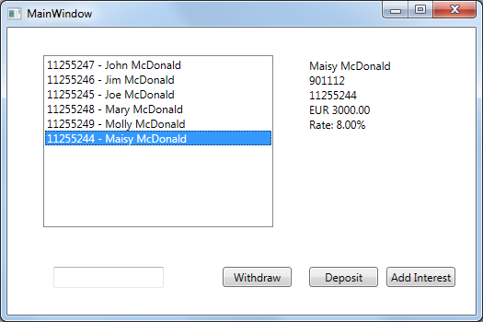

**Exercise 6:**

You need to override the DisplayDetails method in the SavingsAccount to display interest and also implement the Withdraw, Deposit and AddInterest functionality.

**Exercise 7:**

Add Save functionality so that the information is saved to file. Here you will need a method in BankAccount to write to file and you will need to override this in savings account so that it also writes the Interest Rate